Admin

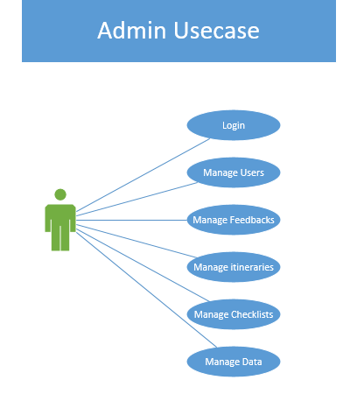

* Admin can login to his account.
* Admin can Manage User Accounts.
* Admin can manage Feedbacks.
* Admin can manage itineraries. E.g. adding or deleting new spots in database.
* Admin can Manage Checklists. E.g. adding new items in checklist database.
* Admin can Manage Complete data of users, itineraries, checklist and wallet.

User

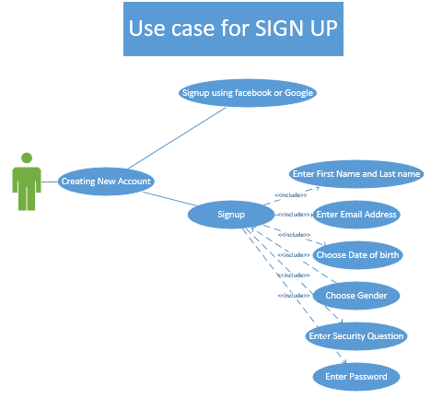

**Signup User Case**

* User can sign up using social media account.

**For tripmate local signup**

* User must enter first and last name
* User must enter email address.
* User must select date of birth
* User must select gender.
* User must choose a Security question and enter its answer.
* User must enter a password

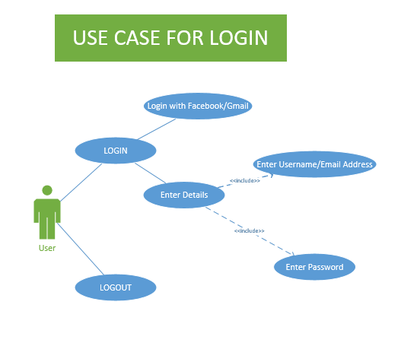

**User Login**

* User can login Through Social Media Accounts such as Facebook and Gmail
* User can also Login with his registered account using his email and password.

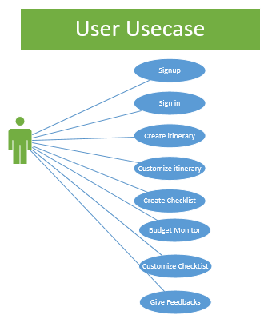

**User Case of User account**

* User can sign in.
* User can create itinerary.
* User can Customize Itinerary.
* User can create checklist.
* User can customize checklist.
* User can monitor budget using our Budget Manager.
* User can give Feedbacks.

Itinerary

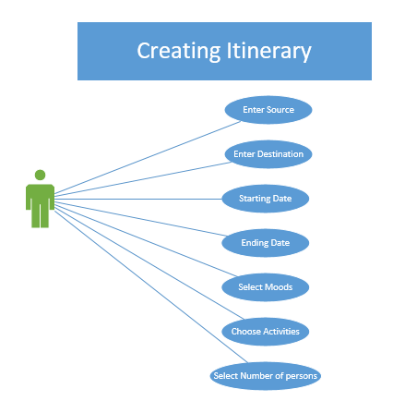

**For Creating Itinerary**

* User will enter source and destination
* User will enter Starting and ending date of trip
* User can select Moods
* User will select activities as well.
* User will also select the number of person.

CheckList

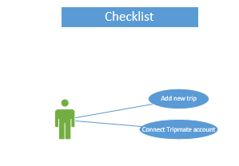

**Checklist Creation**

* User can connect Tripmate account to the Checklist generator
* User can also add a new trip in checklist generator.

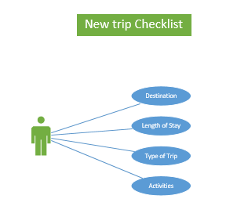

**Adding New trip**

* User will enter Destination
* User will enter length of stay/ Duration of stay
* User can select type of trip e.g. Business or leisure
* User can select activities e.g. Swimming, Hiking, Beach, Photography.

Wallet

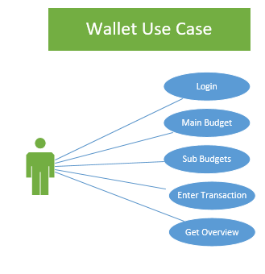

**Wallet User Story**

* User will login to the wallet.
* User can create a Main Budget Consisting Multiple Categories.
* User can create sub budgets of single category.
* User can perform Transaction.
* User can also get overview of the budget according to e.g. Day, Month or category.

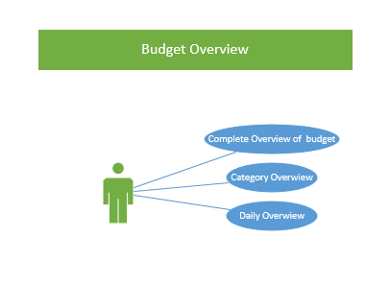

**Budget Overview**

* User can get the complete Overview of the budget.
* User can get the daily Overview of the budget.
* User can get the Budget according to categories.

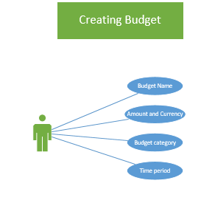

**Creating Budget**

* User will enter the budget name
* User will enter the amount and the currency
* User will select the Budget category
* User will select the Time period of the budget e.g. (1-jan to 30-jan)

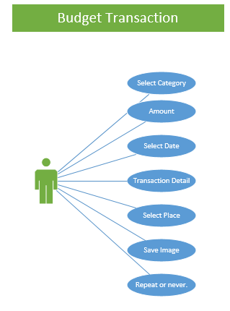

**Budget Transaction**

* User will select the category
* User will enter Amount
* User will select the date of transaction
* User can enter transaction detail as well.
* User can also select the place of transaction.
* User can also save the image of transaction
* User can also choose the mood if the transactions is going to repeat daily or not.

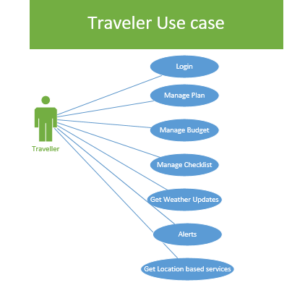

**Traveler Use case**

After our user create account and create itinerary and checklist he becomes traveler.

* Traveler can login
* Traveler can manage plan/itinerary.
* Traveler can manage budget.
* Traveler can manage checklist.
* Traveler will get weather updates.
* Traveler will get Trip alerts.
* Traveler will get location based emergency contacts.